From Everyone at Hitherfield, we wish you a very Happy New Year!

Dates for the Diary

Wednesday 14th January – Year 4 trip to Stockwell Green Mosque

Wednesday 21st January - Reception to Year 6 Parents' Evening
2pm - 7pm
https://hitherfield.schoolcloud.co.uk

Thursday 22nd January – 6 Wolverine trip to Horniman Museum

Wednesday 28th January – Phonics Workshop for Families of Year 1 in the Main Hall 9am – 10am

Volunteering 9am - 10am Thursdays
Yes, the weather is cold but Jessi is still ready to welcome you, on Thursday mornings, into the edible garden. This half term will be focused around pruning our apples, pears, cherries, currants and gooseberries. We will be reusing as much as we can for cuttings. Pop in for a session or two and get hands on experience with pruning and propagating. You can see what kind of edibles we grow around the school and how your children get involved. Pick up new skills and ideas on how to grow your own. No previous experience or knowledge is necessary.
Also, a reminder that Children are welcome in the edible garden only when supervised by an adult before and after school. We ask that the adults ensure that the children are respectful to the garden, only picking what is ready and what they are going to eat, so nothing is wasted.
Friday’s morning adult sessions will resume after the half term.

Nursery Parents' Evening
Wednesday 4th March 1pm - 6pm
Booking system to open at a later date
There will be no afternoon Nursery on this day

Congratulations!

A big thank you to everyone who helped raise £575.81 for new books for the library. Approximately half the money spent on books at the Christmas Book Fair by you is then given to us to spend. This really helps and the children love reading all the latest books we're able to get.

Thank You!!!





Reception Admissions - 2026-2027
If your child was born between 1 September 2021 and 31 August 2022, you must apply for a primary or infant school place for September 2026.
Apply on time and apply online! The deadline for applications is midnight on Thursday 15 January 2026.
https://www.lambeth.gov.uk/schools-and-education/school-admissions-and-appeals/primary-school-admissions/apply-primary-school-place-2026-27

Please only order if your child is in Years 4, 5 or 6

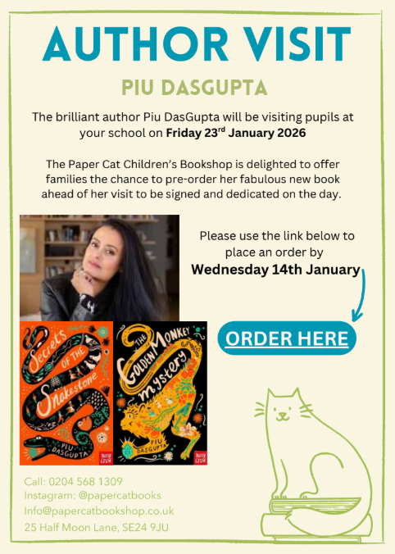

CLICK HERE!



