

GOOD NEWS CARDS
Congratulations to these children who have really impressed their
Teachers this week.
1 COBRA | 1 DUGONG | 1 SUNBIRD
To be announced next week | To be announced next week | To be announced next week
2 MANATEE | 2 MONGOOSE | 2 HUMMINGBIRD
Varvara and Vithun | Alana and Lara | Logan and Emmy
3 JAGUAR | 3 MACAW | 3 ANACONDA
Alex and Rickari | To be announced next week | Esmae and Emily
4 HIPPOPOTAMUS | 4 FLAMINGO | 4 CHEETAH
Leyla and Key | Jonathan and Oscar | Cassius and Owain
5 KINGFISHER | 5 HEDGEHOG | 5 OTTER
Daisy and Baillo | Matteo and Nicholas | Ishmaheel & Noura
6 ORCA | 6 PUFFIN | 6 WOLVERINE
Meshach and Dorry | Idrees and Mason | Issac and William

Nut Aware
To help keep everyone safe, please remember that our school is nut-aware. We have children with airborne nut allergies, so we kindly ask that no foods containing nuts are sent to school.
Thank you for your support and understanding.

Dates for the Diary

Wednesday 4th February – 1 Cobra Class Assembly and Open Morning 9:15am – 10:30am

Thursday 5th February – 1 Dugong Class Assembly and Open Morning 9:15am – 10:30am

Friday 6th February – 1 Sunbird Class Assembly and Open Morning 9:15am – 10:30am

Tuesday 10th February – 3 Jaguar Class Assembly and Open Morning 9:15am – 10:30am

Wednesday 11th February – 3 Anaconda Class Assembly and Open Morning 9:15am – 10:30am

Thursday 12th February – 3 Macaw Class Assembly and Open Morning 9:15am – 10:30am

Friday 13th February – Last Day of Term

Football Clubs with Lionel

Please be advised that the following football clubs have been cancelled, as Lionel will not be available

Thursday 5th Feb - Year 4-6 Football Squad
Friday 6th Feb - Girls Football Squad
Tuesday 10th Feb - Year 4 Football
Wednesday 11th Feb - Years 5-6 Football
Thursday 12th Feb - Year 4-6 Football Squad
Friday 13th Feb - Girls Football Squad

Please Click Here for all Streatham and Norwood Better Start Information.

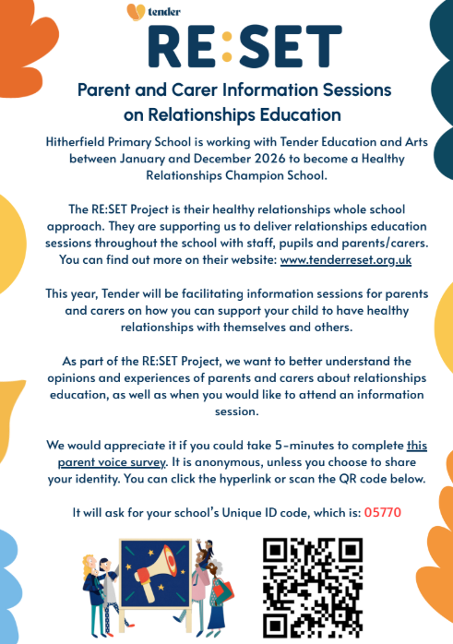

https://tenderreset.org.uk/

We would appreciate it if you could take 5-minutes to complete The Parent Voice Survey. It is anonymous, unless you chose to share your identity. You can click the hyperlink or scan the QR code below. It will ask your school’s Unique ID code, which is: 05770

CLICK HERE FOR THE PARENT VOICE SURVEY

