School Finances Update

As previously shared, the school’s finances continue to be under a lot of strain due to many, many years of real term cuts to the amount of funding schools, particularly schools in London, receive. Schools in England are funded on a per pupil basis and the amount of money the school receives per pupil has not kept pace with cost increases, such as the cost of electricity, the cost of resources and the cost of staff.

You may be aware that the country is experiencing a general fall in the birth rate and Lambeth has seen a drop in the number of children going into Reception Classes this year, compared to 2018, of approximately a third. Between 2020 and 2025 alone, the number of children starting in Lambeth Reception Classes reduced by over 500, which is the equivalent of more than 16 whole Reception Classes. As a borough, Lambeth schools have worked closely together to reduce the number of Reception Classes in schools and you may be aware that some of our local schools have dropped from 3 forms of entry to 2 forms of entry, or from 2 forms of entry to 1 form of entry. This has happened across the borough, but it still hasn’t solved the problem, so Lambeth Council has been looking into amalgamating or closing some schools (not Hitherfield). In addition to this, the legacy of Brexit and the Covid pandemic also impacts Lambeth and London schools, as when families move out of London there are now less children arriving into London to replace them.

At Hitherfield we are proud that the community wishes to have their children education at our lovely school. We continue to receive more first preference applications for Reception Classes than we have spaces (90). This means we are oversubscribed for Reception each year (including September 2026) and we continue to be a three-form entry school. However, even we are seeing the Brexit and Covid impact as children move through the school. Some of our year groups have far less than the 90 children they started out with in Reception. We now see a trend of some families leaving London, or Lambeth, each year and whilst we welcome some new families into the school the trend is that between Reception and our current Year 5 class the number of children drops each year. For example, we currently have 69 children in Year 5.

As mentioned above, schools are funded on a per pupil basis, so if a year group is not full, schools receive less funding, yet they still have to ensure every class has a teacher, children’s learning is supported and resourced, the school premises are safe etc.. Therefore, schools are seeing huge financial challenges from two directions - less children equals less money and the amount of money per child has fallen in real terms compared to cost increases. This is why I have been vocal in my support for the Stop School Cuts Campaign https://schoolcuts.org.uk/

So, how has Hitherfield managed this so far? The largest cost of any school is the costs of staff. Therefore, to manage the budget successfully, the school has had to reduce staffing. Over the last decade we have gradually reduced our staff team. Luckily, we have been able to do this by not replacing staff when they have left the school. A snapshot of this reduction is that the Senior Leadership Team has shrunk by 4 full-time out of class staff, the number of full-time equivalent teachers in the school has been reduced by 5 and we have also significantly reduced the number of specialist English as an Additional Language Teaching Assistants, Learning Mentors and other Teaching Assistants. All of these actions have ensured the school remains financially stable, but the future looks increasingly challenging as there is a lack of clarity of education funding going forward. This means that the school continues to have to look at further ways to reduce costs on top of what has been undertaken already.

What can you do to help? The school is very well supported by the community, especially through the PTA. We are more reliant on the money the PTA raises on behalf of the school. Whist this money does not go towards staff costs, it does pay for improvements to the school grounds (think Trim Trail etc) and special events (think Year 5’s Primary Shakespeare Project and the Christmas pantos) and to some basic resourcing (think books). The PTA always need more support, so please contact them if you can help hitherfieldpta@gmail.com . You could make you voice heard by contacting your MP or joining the Stop School Cuts Campaign and I also know that many families have very kindly donated money to the school via our School Business Manager, Arlette arlettewells@hitherfield.co.uk .

It is very saddening that in 2026 London schools are struggling financially. I will keep you abreast of further developments and I thank you as always for ongoing support for Hitherfield and the staff team.

Kind regards,
Chris Ashley-Jones,
Executive Headteacher

School grounds development
We are currently seeking quotations for a landscaping project at the school and would like to invite interested members of our wider community to get in touch.
The project involves the construction of a retaining wall using wooden sleepers, along with backfilling the area with soil. A detailed job specification is available and will be shared with those who express interest in providing a quote.
To be considered for this work, individuals or companies must meet the following requirements:
- Hold a valid Enhanced DBS certificate
- Be VAT registered
- Have demonstrable experience in carrying out similar landscaping or construction work
- Hold appropriate public liability insurance
If you are interested or know someone within our community who may be suitable, please contact the Facilities Team at premises@hitherfield.co.uk to request the full specification and further details.
We look forward to hearing from you.

Dates for the Diary

Monday 27th April – Class 4 Cheetah and 4 Flamingo trip to National Maritime Museum

Wednesday 29th April – Robin and Tadpole Class Assembly and Open Morning
9:30am – 10:30am

Wednesday 29th April - Parents’ Evening 2pm – 7pm Reception – Year 6

Friday 1st May – 3 Macaw trip to The British Museum

Monday 4th May – School Closed - Bank Holiday Monday

Tuesday 5th May – Reception Vision Screening

Wednesday 6th May – Koala Class Assembly and Open Morning
9:15am – 10:15am

Thursday 7th May – WHOLE SCHOOL CLOSED – LOCAL ELECTION

Friday 8th May – Kookaburra Class Assembly and Open Morning
9:15am – 10:15am

Monday 11th – Thursday 14th May – Year 6 SATs

Thursday 14th May – 3 Anaconda trip to The British Museum

Monday 18th May – 4 Hippo trip to National Maritime Museum

Thursday 21st May - Platypus Class Assembly and Open Morning
9:15am – 10:15am

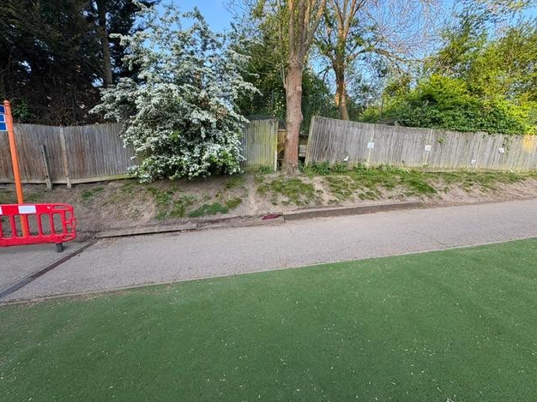



GOOD NEWS CARDS
Congratulations to these children who have really impressed their
Teachers this week.
1 COBRA | 1 DUGONG | 1 SUNBIRD
To be announced next week | Fatoumata and Lina | Elle and Nina
2 MANATEE | 2 MONGOOSE | 2 HUMMINGBIRD
Nyraiyah and K’Lynn | Bronwen and Eshan | Esme and Ida
3 JAGUAR | 3 MACAW | 3 ANACONDA
Sophia H and Rickari | Tommaso and Daniel | Rowan and Hanan
4 HIPPOPOTAMUS | 4 FLAMINGO | 4 CHEETAH
Finley and FE | To be announced next week | Franklin and Raeann
5 KINGFISHER | 5 HEDGEHOG | 5 OTTER
Beatrice & Sephy | Salimatou & Isaiah | Maria and Ishmaheel
6 ORCA | 6 PUFFIN | 6 WOLVERINE
Isabelle and Zoe | Adam and Abraham | Khallah and Maryam

Lambeth School Holiday Survey

Lambeth Council is responsible for setting the standard school term and holiday dates for all community, community special, and maintained nursery schools in the borough.

To support families, school leaders, governors, staff, service providers, and other organisations working with schools and young people, Lambeth works in coordination with other London boroughs to propose term dates. This helps with planning work commitments, holidays, and significant family events.

Community schools are required to follow these dates. However, voluntary aided, foundation, foundation special schools, and academies determine their own term dates through their governing bodies or trustees, although they are encouraged to align broadly with the Council’s schedule.

What is this survey about?
We are seeking your views on the proposed dates for the 2027/28 academic year, which must consist of 195 days as required by law. This includes 190 pupil attendance days and five professional development days (also known as INSET days). Bank and public holidays have been taken into account.

We would like your views
School term dates must comply with national regulations set by the Department for Education and take account of exam timetables. Within these constraints, there is some flexibility in how the school year is structured.
We would like to understand whether you feel the current pattern of term dates works well, or whether you would prefer a different balance between term lengths and school holidays across the year. This survey provides an opportunity to share your views and suggest any changes for consideration.

We welcome feedback from all stakeholders, including families, schools, and governors.

The survey is open until Thursday 8 May 2026. To submit your views, please click here to complete the survey.

Plant Sale

This year we are doing the plant sale for the summer fair differently. The summer fair will be a little late for some crops or flowers you might want to have planted out by then. So we will have some plants available for sale in the greenhouse on Wednesdays around pick up time. This first Wednesday we will have courgettes, currants, some herbs (mostly mint), sunflowers and other edible flowers. Get your kids growing, have food with zero food miles and no packaging and support the PTA.

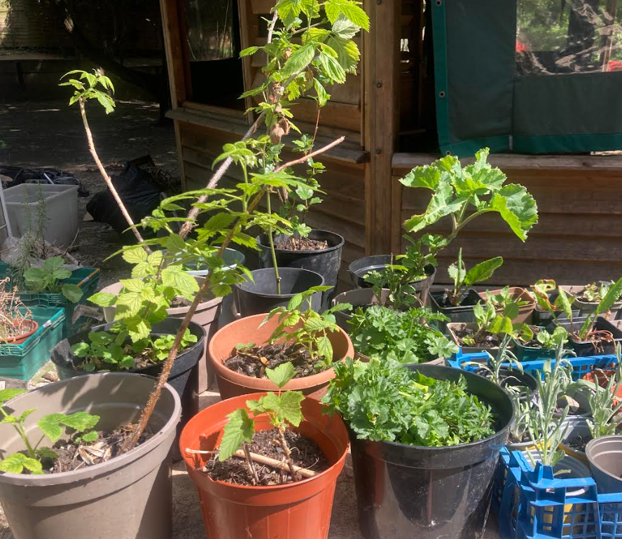



Sports’ Day
Friday 15th May – Year 1 & 2 9:15am – 11:40am
Wednesday 20th May - Nursery and Reception 9:30am – 11:30am
Friday 22nd May – Year 5 & 6 9:15am – 2pm
Wednesday 3rd June – Year 3 & 4 9:15pm – 2pm
Parents can take children home at the end of the Sports’ Day for Years 3 – 6




Hitherfield’s Sports’ News



Yesterday, some of our Year 4 students had an exciting opportunity to attend a Cricket Skills Festival as part of the T20 Women’s World Cup Schools Day, organised by the Surrey Cricket Foundation.
The fun and active festival was designed to help pupils develop key movement skills, build confidence, and work together as a team. There was even national media present, including Sky TV and Newsround!
A real highlight of the day was meeting Heather Knight, an England international cricketer and former captain of the women’s team. The students were thrilled to meet her and were delighted to have their T-shirts signed.
Each child received a T20 World Cup T-shirt, stickers, a certificate, posters, and a T20 Women’s World Cup wristband to remember the day.
Everyone had a fantastic time! As a bonus, by attending the festival, the school has been automatically entered into a prize draw for the chance to win a softball kit bag for the school, as well as tickets to the semi-final of the T20 Women’s World Cup at Kia Oval this summer.
Wish us luck!



Dear Families,
Following a successful launch last year, we’re excited to open bookings for R3 Voyage Kids Club this May Half Term at Hitherfield Primary School.
The club will run from Tuesday, 26th May to Friday, 29th May.
R3 Voyage Kids Club is designed for children aged 5–11 years and offers a fun, engaging mix of off-site trips and on-site activities. Children will travel safely on all trips using our private minibus, and the club is Ofsted-registered.
Please see the attached flyer for a visual overview of what we have planned.
Planned experiences include:
• Polka Theatre visit
• Rock climbing
• Multi-sports (football, tennis and boxing)
• Slime workshops and baking and creative activities
• Cinema trips

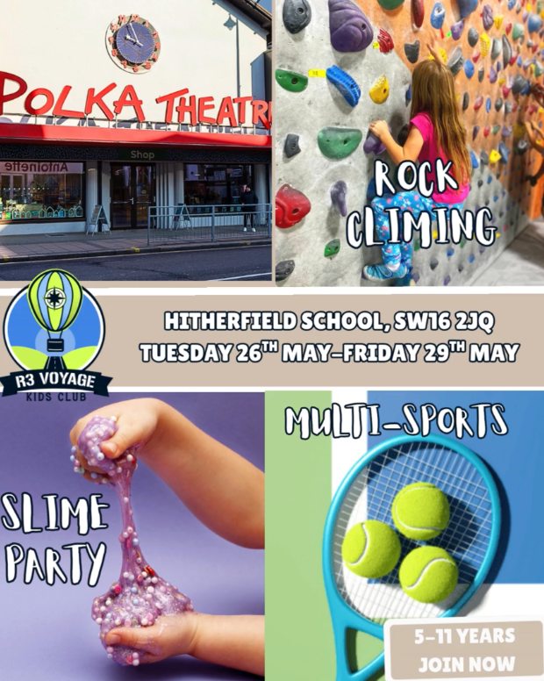
What we offer:
• Trips and activities included
• Childcare vouchers and Tax-Free Childcare accepted
• Small group sizes with experienced and qualified staff
• Safe minibus transport for off-site trips
• Based at Hitherfield Primary School
Bookings are now open.
You can book directly via:
https://r3-voyage-kids-club.classforkids.io/camp/4
Or visit our website:
www.r3voyagekidsclub.com
If you have any questions, please feel free to get in touch. We would love to welcome your child for a fun, safe and memorable holiday club experience.





