Support and Respect

We have all been saddened and deeply upset by the spate of antisemitic attacks happening in our city and beyond. Hitherfield, as always, is a place of hope, love and peace. We support every part of our school community and send our love and best wishes to anyone and everyone affected.

Dates for the Diary

Monday 4th May – School Closed - Bank Holiday Monday

Tuesday 5th May – Reception Vision Screening

Wednesday 6th May – Koala Class Assembly and Open Morning
9:15am – 10:15am

Thursday 7th May – WHOLE SCHOOL CLOSED – LOCAL ELECTION

Friday 8th May – Kookaburra Class Assembly and Open Morning
9:15am – 10:15am

Monday 11th – Thursday 14th May – Year 6 SATs

Thursday 14th May – 3 Anaconda trip to The British Museum

Monday 18th May – 4 Hippo trip to National Maritime Museum

Thursday 21st May - Platypus Class Assembly and Open Morning
9:15am – 10:15am

Class photo proof cards were distributed last week. If you have already set up an account on the website, you won’t have received a proof card, but you can log in to view your photo.
https://orderphotos.mhullphotography.com/



OUTDOOR ADVENTURE DATES

Friday 5th June - Year 5 Camping overnight on school grounds

Tuesday 9th June - Year 1
(afterschool from 3:30 - 6pm)

Wednesday 10th June - Year 3
(afterschool from 3:30 - 7pm)

Monday 15th June - Year 2
(afterschool from 3:30 - 6pm)

Friday 3rd July - Year 4 Sleepover in school

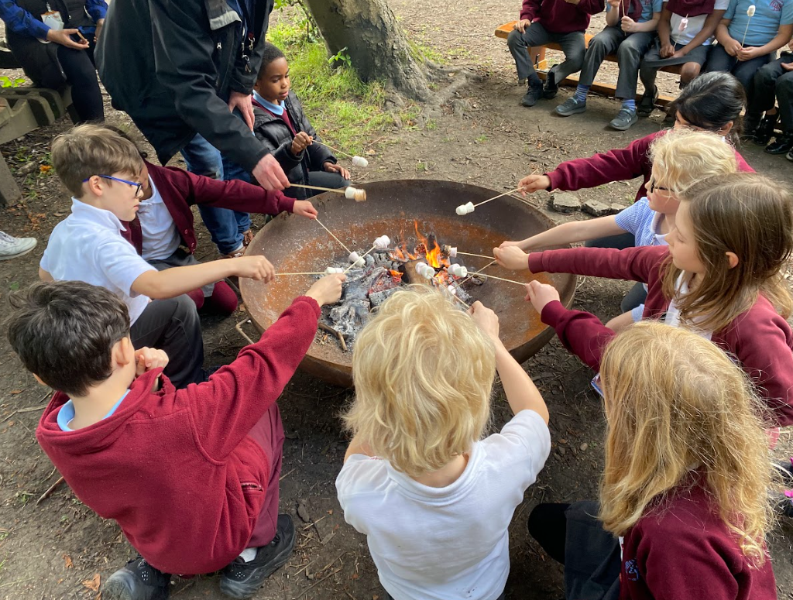



GOOD NEWS CARDS
Congratulations to these children who have really impressed their
Teachers this week.
1 COBRA | 1 DUGONG | 1 SUNBIRD
Antoni and Olivia | To be announced next week | Zanayah and Jude
2 MANATEE | 2 MONGOOSE | 2 HUMMINGBIRD
Frankie and Yannis | To be announced next week | Aquila and Kaliyah
3 JAGUAR | 3 MACAW | 3 ANACONDA
Sophia H and Alex | Cole and James | Zahara and Adriel
4 HIPPOPOTAMUS | 4 FLAMINGO | 4 CHEETAH
To be announced next week | To be announced next week | Arlo and Cassius
5 KINGFISHER | 5 HEDGEHOG | 5 OTTER
Dexter & Marwa | To be announced next week | Ted & Lola
6 ORCA | 6 PUFFIN | 6 WOLVERINE
Michael and Joe W | Sami and Aiyana | Robert and Oliver

Sports’ Day
Friday 15th May – Year 1 & 2 9:15am – 11:40am
Wednesday 20th May - Nursery and Reception 9:30am – 11:30am
Friday 22nd May – Year 5 & 6 9:15am – 2pm
Wednesday 3rd June – Year 3 & 4 9:15pm – 2pm
Parents can take children home at the end of the Sports’ Day for Years 3 – 6






We Did It! Mini London Marathon Success!
Over the past three weeks, pupils from Reception right through to Year 6 have taken on an exciting challenge—and absolutely smashed it! All 564 children worked towards completing a two-mile distance, together achieving an incredible total of 1,128 miles.
This fantastic effort has been about so much more than just running. Throughout the challenge, pupils have shown outstanding determination, resilience, collaboration, and a willingness to take on new challenges. Most importantly, they’ve embraced the joy of being active and supporting one another along the way! We are super proud of everyone that took part.
Go Team Hitherfield! 🎉

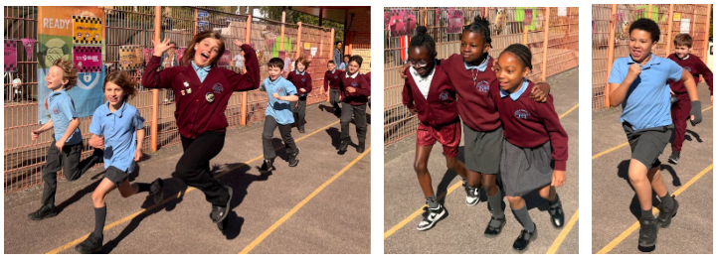

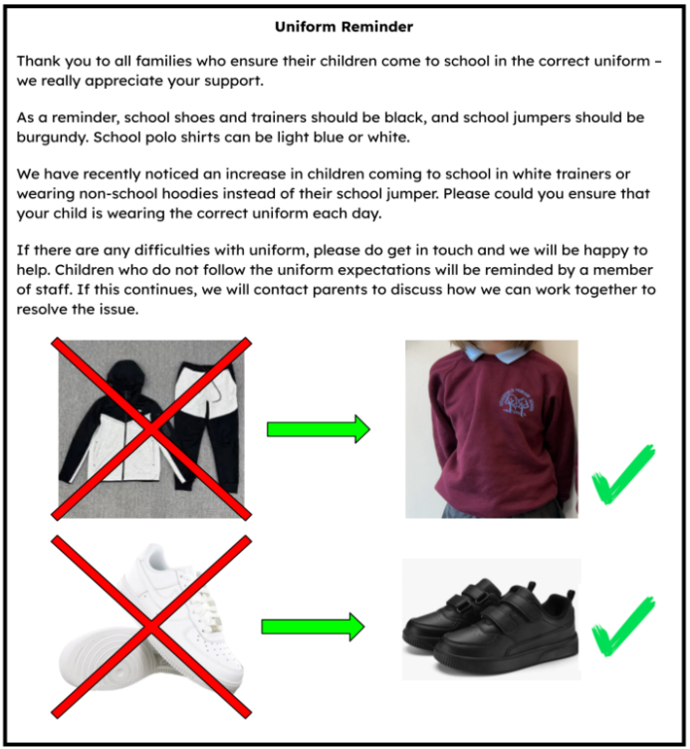



Dear Families,
Following a successful launch last year, we’re excited to open bookings for R3 Voyage Kids Club this May Half Term at Hitherfield Primary School.
The club will run from Tuesday, 26th May to Friday, 29th May.
R3 Voyage Kids Club is designed for children aged 5–11 years and offers a fun, engaging mix of off-site trips and on-site activities. Children will travel safely on all trips using our private minibus, and the club is Ofsted-registered.
Please see the attached flyer for a visual overview of what we have planned.
Planned experiences include:
• Polka Theatre visit
• Rock climbing
• Multi-sports (football, tennis and boxing)
• Slime workshops and baking and creative activities
• Cinema trips

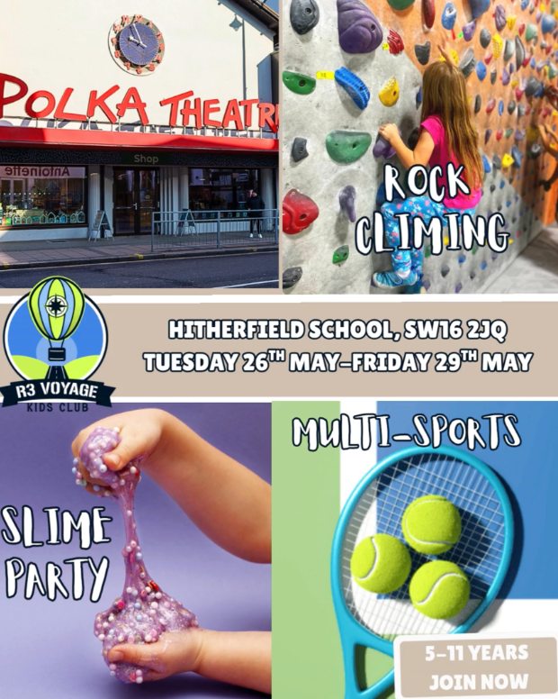
What we offer:
• Trips and activities included
• Childcare vouchers and Tax-Free Childcare accepted
• Small group sizes with experienced and qualified staff
• Safe minibus transport for off-site trips
• Based at Hitherfield Primary School
Bookings are now open.
You can book directly via:
https://r3-voyage-kids-club.classforkids.io/camp/4
Or visit our website:
www.r3voyagekidsclub.com
If you have any questions, please feel free to get in touch. We would love to welcome your child for a fun, safe and memorable holiday club experience.



CLICK HERE



