Introducing the Hitherfield Friday Maths Challenge
We are excited to introduce a new initiative - the Hitherfield Friday Maths Challenge! Each Friday at lunchtime in the KS1 and KS2 lunchhall, two fun maths problems will be displayed on the large screen. We will be encouraging children to talk about the problems with the children on their tables while they are eating lunch and try to find answers (though this is not compulsory!).
We will also post the questions in the Hitherfield Herald each week and the answers will be given and discussed during KS1 and KS2 Good News assemblies the following week. We’re hoping the questions will prompt interesting conversations about maths, both at school and at home, and raise the profile of reasoning and problem solving in a relaxed, thought-provoking way.
Here are this week’s problems – good luck!
Jo and Martine
Hitherfield Maths School Improvement Leaders

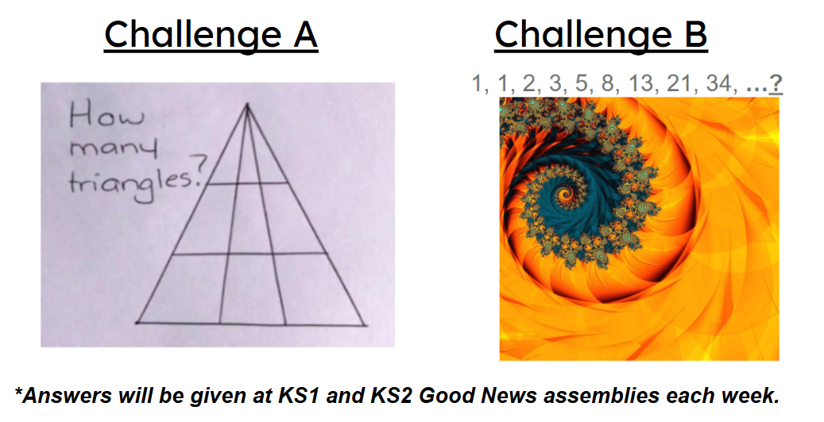

Dear Families of Koala Class,
Please note that both Breakfast and Afterschool Club sessions for Koala Class are held in the Children's Centre on Mondays to Thursdays and in the Infant Hall on Fridays. Thank you.
BASC Team

Can you be a Hitherfield Hero reading volunteer?
For the past few years, we have had incredible success with our Hitherfield Hero reading programme, ensuring every class in the school has had a volunteer reader from the community at least once a week! This had an incredible impact on our readers and we want to do that again this year.
We are calling on anyone who is able to donate at least 30 minutes a week of their time to the school (either 9-9.30am or 3-3.30pm) to help target children learn to read.
In each class, from Reception to Year 6, there are children who need YOUR help to maximise their progress.
You would be assigned a class, and listen to three children read once a week on a day to suit you. This one-to-one reading has an incredible impact- just five minutes reading a day can make a huge difference to fluency and comprehension!
Sadly, with the cuts to education funding, the school has less and less staff in order to achieve this targeted, often one-on-one, support. This is why we need YOU!
As the school must pay for DBS checks, we ask for a minimum 6-month commitment.

Please fill in the following Google Form to provide us with the required information: https://forms.gle/Q7oKHWh71Hghza248
Thank you, thank you… THANK YOU!

Gemma Jackson, Reading Lead.

Price increase for BASC and nursery school dinner prices are going up from September 2026

Nursery to yr 6
BC: £9 per session
ASC £16 per session
Ad-hoc sessions will be:
£15 BC
£25 ASC

Nursery school dinner will now be charged at £2.70 per day. As always please ensure all payments for BASC and school dinners are paid for in advance.

Also please note that both Breakfast and Afterschool Club are now full. If you need to apply for a space the application form is on our website. Your child will then be added onto our waiting list and you will be contacted once a space becomes available.

Dates for the Diary

Monday 14th September – Friday 18th September – Year 6 to PGL

Wednesday 16th September – Reception – Year 5 Class Social

Friday 18th September – PTA AGM 9:15am – 10:15am

Wednesday 23rd September Nursery & Year 6 Class Social

Friday 25th September – PTA McMillan Coffee Morning 9am – 11am

Wednesday 14th October – Parents’ Evening Reception to Year 6

EDIBLE GARDEN
Volunteering 9:00 - 9:45am Thursdays


Drop in sessions in the edible garden for adults have begun. Jessi will be waiting by the garden gate outside the reception classrooms from 9am Thursday mornings. Come when it suits you. You can see what kind of edibles we grow around the school and how your children get involved. Pick up new skills and ideas on how to grow your own. The summer was super hot so the garden has gone a little wild. Autumn term we have started with some taming, we will sort out the apples, plant up the new planter we build last term by the library and in December you can learn how to prune and propagate berry bushes.



As a reminder Children may enter only when supervised by an adult.
…before and after school. We ask that the adults ensure that the children are respectful to the garden, only picking what is ready and what they are going to eat, so nothing is wasted. We do not use pesticides or herbicides for the children’s safety so there may be a worm in the currently ripe apples. Please do not allow them to pick one if they are likely to discard it. We teach the children to cut the worm out or eat around them. You are welcome to take windfall apples home. They make great crumble.



